NLP Final Project Report

Linxuan Yan 1002198

Linwei Li 1002199

Xingxuan Li 1002189

# Part 1-4

## How to run

See README.txt

## Approaches

We implemented Viterbi algorithm as follows:

$$V\left(j,i\right)=\max_{j'}{V(j^{'},i-1)+tran\left(j^{'},j\right)+emi\left(j,sent\left(i\right)\right)} \\ emi\left(j,sent\left(i\right)\right)=0 if \left(j,sent\left(i\right)\right) is not an emission feature$$

We implemented forward-backward algorithm as follows:

$$alpha\left(j,i\right)= {Logsumexp}_{j^{'}}\left(alpha\left(j^{'},i-1\right)+tran\left(j^{'},j\right)+emi\left(j,sent\left(i\right)\right)\right)$$

$$beta\left(j,i\right)= {Logsumexp}_{j^{'}}\left(beta\left(j^{'},i+1\right)+tran\left(j,j'\right)+emi\left(j',sent\left(i+1\right)\right)\right)$$

We calculated the expected count of a feature as follows:

$$Transition f_{123}=transition:u+v$$

$$E_{y|x}\left[f_{123}\left(x_{i},y\right)\right]=\sum_{i=1}^{n}{exp⁡(alpha\left(u,i-1\right)+tran\left(u,v\right)+emi\left(v,sent\left(i\right)\right)+beta\left(v,i\right)-total)}$$

$$Emission f_{124}=emission:u+x$$

$$E_{y|x}\left[f_{124}\left(x_{i},y\right)\right]=\sum_{i=1}^{n}{exp⁡(alpha\left(u,i\right)+beta\left(u,i\right)-total)} if sent\left(i\right)=x$$

Result

### EN part 2

**‘/EN/dev.p2.out’**

#Entity in gold data: 210

#Entity in prediction: 154

#Correct Entity : 103

Entity precision: 0.6688

Entity recall: 0.4905

Entity F: 0.5659

#Correct Sentiment : 71

Sentiment precision: 0.4610

Sentiment recall: 0.3381

Sentiment F: 0.3901

### EN part 3

Loss using features from part 1: 2050.740533835358

### EN part 4

**‘/EN/dev.p4.out’**

#Entity in gold data: 210

#Entity in prediction: 139

#Correct Entity : 104

Entity precision: 0.7482

Entity recall: 0.4952

Entity F: 0.5960

#Correct Sentiment : 73

Sentiment precision: 0.5252

Sentiment recall: 0.3476

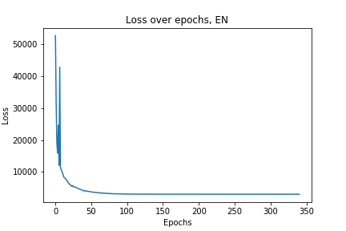Sentiment F: 0.4183

### ES part 2

**‘/ES/dev.p2.out’**

#Entity in gold data: 235

#Entity in prediction: 177

#Correct Entity : 133

Entity precision: 0.7514

Entity recall: 0.5660

Entity F: 0.6456

#Correct Sentiment : 104

Sentiment precision: 0.5876

Sentiment recall: 0.4426

Sentiment F: 0.5049

### ES part 3

Loss using features from part 1: 2676.6770981798413

### ES part 4

**‘/ES/dev.p4.out’**

#Entity in gold data: 235

#Entity in prediction: 147

#Correct Entity : 117

Entity precision: 0.7959

Entity recall: 0.4979

Entity F: 0.6126

#Correct Sentiment : 93

Sentiment precision: 0.6327

Sentiment recall: 0.3957

Sentiment F: 0.4869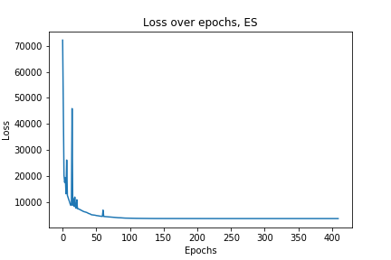

# Part 5

Approaches

In part 5, we use Bi-LSTM CRF. The reason why we use this model is that although LSTM is sufficient for this task, a sequence model like CRF is really essential for strong performance on the task. Following is the computation of a conditional probability for CRF.

Overall Architecture:

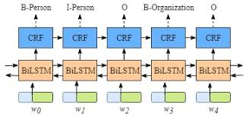

Bi-LSTM Cell

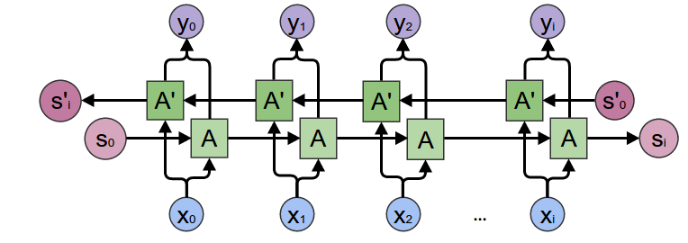

$$P\left(x | y\right)=\frac{\exp\left(Score\left(x,y\right)\right)}{\sum{\exp\left(Score\left(x,y^{'}\right)\right)}}$$

The score in the above equation is determined by some log potentials such as:

$$Score\left(x,y\right)= \sum{logp\left(x,y\right)}$$

Since in the Bi-LSTM CRF, we have both emission and transition. We have the following actual equation for score.

$$Score\left(x,y\right)= \sum_{i}{logp_{emit}\left(y_{i} to x_{i}\right)+logp_{trans}(y_{i-1} to y_{i})}$$

$$Score\left(x,y\right)= \sum_{i}{h_{i}\left[y_{i}\right]+ P_{y_{i},{ y}_{i-1}}}$$

Following are the results:

**EN**:

#Entity in gold data: 210

#Entity in prediction: 147

#Correct Entity : 107

Entity precision: 0.7279

Entity recall: 0.5095

Entity F: 0.5994

#Correct Sentiment : 67

Sentiment precision: 0.4558

Sentiment recall: 0.3190

Sentiment F: 0.3754

**ES**:

#Entity in gold data: 235

#Entity in prediction: 147

#Correct Entity : 117

Entity precision: 0.7959

Entity recall: 0.4979

Entity F: 0.6126

#Correct Sentiment : 93

Sentiment precision: 0.6327

Sentiment recall: 0.3957

Sentiment F: 0.4869